Pbus fault-Forth&Mega

Author：胡维
Reviewer:Eason

FAQ/String Inverter
Issue introduction
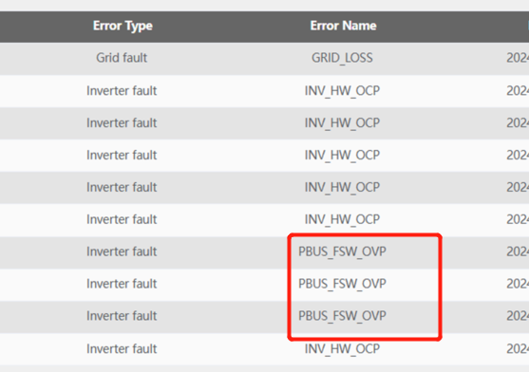
Confirmation of basic information
[Photo]SN numbers of the inverter.
Guidance for installer
Step1: Use a multimeter to measure the voltage of each string of photovoltaic panels,and the he measured voltage should be within the MPPT range.If the measured voltage value is close to the maximum MPPT range threshold, it is recommended to reduce the number of photovoltaic panels in the corresponding string.
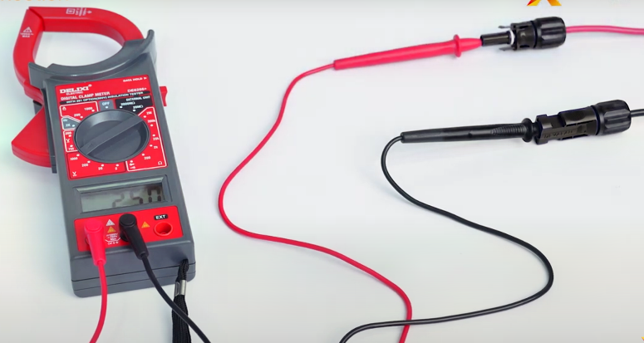
Step2:Use a multimeter to measure the voltage at the inverter's AC port. In a three-phase system, measure the line voltage.
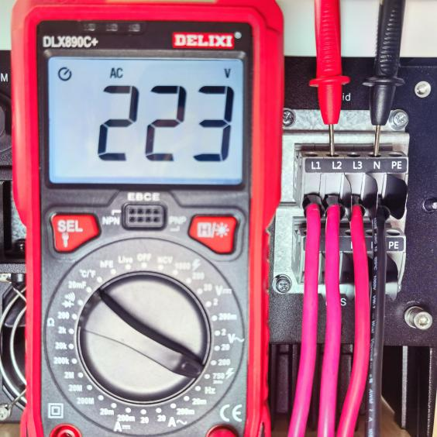 | 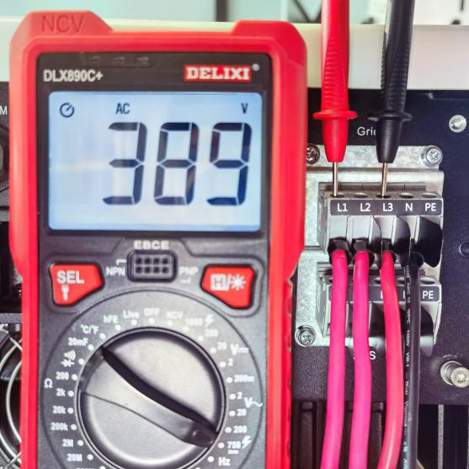
Phase voltage on the grid side | Line voltage(line voltage＝√3×Phase voltage)
Step3:Upgrade the firmware version to the latest.
Information check list
If you have completed the above <Guidance for installer>, and the problem is still not solved, please collect the following troubleshooting information and send them to the R&D.
1.[Photo]SN numbers of the inverter.
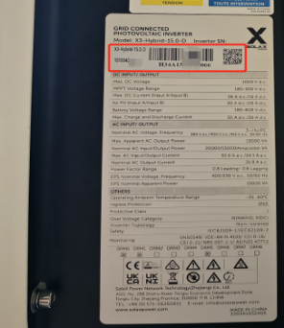
2.[Photo]Voltage data on the PV side.
3.[Photo]The line voltage between L1&L2, L2&L3, L1&L3 and the phase voltage between L1&N, L2&N, L3&N at the AC side.
